**Infosys**

**Edgeverve**

**PROCESS DEFINITION**

**INFOSYS TECHNOLOGIES LIMITED**

**Bangalore**

|  |  |  |  |
| --- | --- | --- | --- |
| **Created By:** | **Bharti Sharma** | **Ver. Rev. :** | **1.0** |
| **Authorized by:** | **Sushma I** | **Signature/:**  **Date:** | **20-April-2020** |

**COPYRIGHT NOTICE**

© 2010 Infosys Technologies Limited, Bangalore, India. All rights reserved. Infosys believes the information in this document is accurate as of its publication date; such information is subject to change without notice. Infosys acknowledges the proprietary rights of other companies to the trademarks, product names and such other intellectual property rights mentioned in this document. Except as expressly permitted, neither this document nor any part of it may be reproduced, stored in a retrieval system, or transmitted in any form or by any means, electronic, mechanical, printing, photocopying, recording or otherwise, without the prior permission of Infosys Technologies Limited and/or any named intellectual property rights holders under this document.

Infosys Technologies Limited

Hosur Road

Electronic City, 3rd Cross

Bangalore 560 100

India.

Telephone: (91) (80)28520 261-270

Fax: (91) (80) 8520 362

Website: <http://www.infosys.com>

**Author (s):** Bharti Sharma

**Reviewer:** Sushma I

**Date Written:** 20-April-2020

**Declarations:**

1) To the best of our knowledge, this document does not contain any material that infringes the copyrights of any other individual or organization including the customer of Infosys.

2) The images used in my document is purely developed by myself without any external references/documents or other user manuals.

3) Images shown in this document are taken from Demo Instance.

**Project Details:** NA

**Target Readers:** Support personnel, New joiners in Finacle, Implementation team.

**Module:** CRM

**Keywords:** Process Definition, Process Creation, Process Setup

**Abstract:** This document gives an overview of how a process for CIF is created.

**Table of Contents**

Introduction 5

Features Supported 5

Process Setup 6

**New Process Creation** 7

**Process Definition Screen** 9

**Add Step** 11

***Basic tab*** 12

***Attachments tab*** 16

***Daemon Details tab*** 17

***Application Call Details tab*** 18

***Routing and Escalation details tab*** 19

# Introduction

A Process is a defined sequence of steps which should be executed for compliance of the systems and procedures of the bank. Some of the process steps to be complied within the system can be automated to save time and ensure consistency and accuracy. Certain steps which require manual intervention are handled by the users who possess the necessary skill sets.

The critical requirement of any business process is compliance with timeliness. Any delay in completing one or more steps of the process can delay an entire process. In this case, banks may prefer escalations to the concerned authorities. Bank may need to configure multiple process to consider all the above-mentioned aspects.

In this document we will go through the details of defining a process.

Features Supported

# Process Setup

o create or update a process, a user should login with admin access.

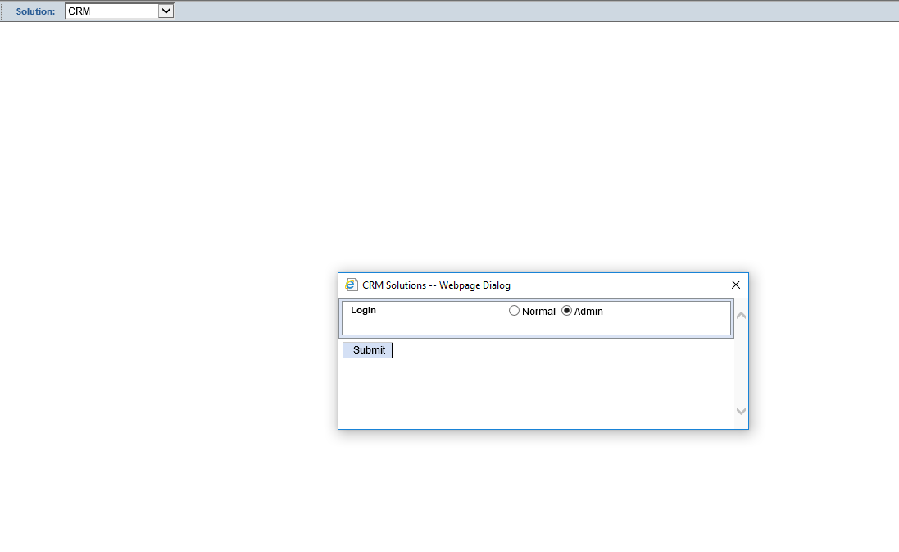

*Figure 1: Admin Login*

After login, user will see the menu tree with the Admin menus.

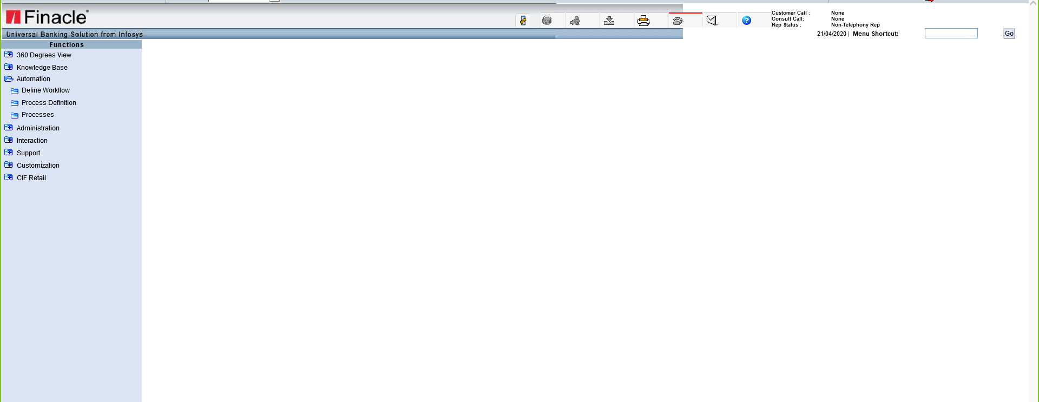

*Figure 2: Admin Landing screen*

## **New Process Creation**

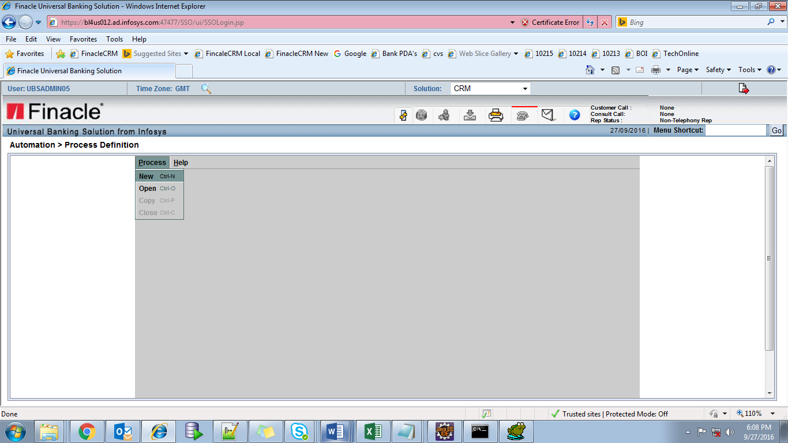

*Figure 3: Open New Process*

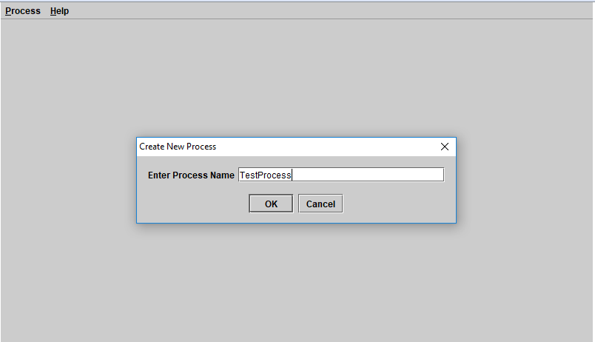

*Figure 4: New Process Name*

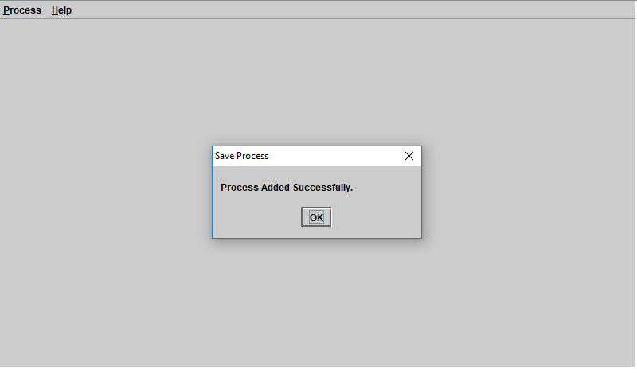

*Figure 5: New process added*

## **Process Definition Screen**

General Information about the process is provided here.

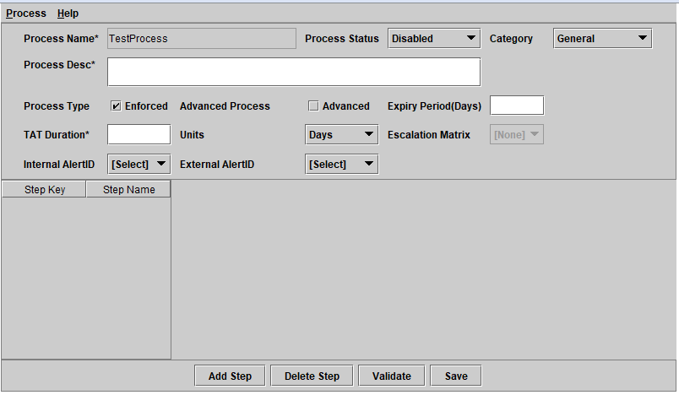

*Figure 6: New Process Creation Screen*

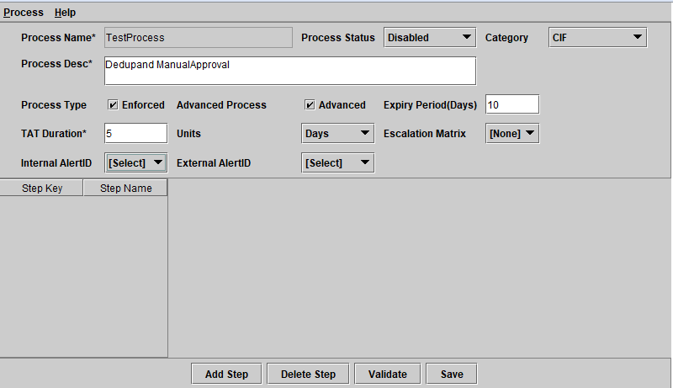

*Figure 7: Valid values added in the relevant fields for new CIF Process creation*

|  |  |  |
| --- | --- | --- |
| Field | DB Field | Details |
| Process Name | Processes.ProcessName | The field value gets defaulted with the Process name defined while creating a new process and is protected. The Process name is available as a drop-down for process selection in the respective modules. |
| Process Status | Processes.IsDisabled | Only processes which are in the enabled status are available for deployment. The processes which are currently deployed to any entity cannot be disabled. Processes which are in enabled status cannot be modified. |
| Category | Processes.ProcessType | Identifies the module for which the process is created e.g. CIF, CampTgt, General, Support etc. |
| Process Desc | Processes.ProcessDesc | Provides description and more information on the process |
| Process Type | Processes.IsEnforced | Indicate whether the process steps are executed sequentially as per the set up or can be executed in parallel. Currently only sequential step execution is allowed. |
| Advanced Process | Processes.IsAdvancedProcess | If advanced process is checked, routing matrix, user or groups can be specified for each of the manual steps for assignment/transfer or steps can be configured as automated steps where a daemon does the processing without any manual intervention. |
| Expiry Period(Days) | Processes.ProcessExpiryPeriod | The validity period of the process specified in terms of number of days is displayed. There is no validation associated for this field currently. |
| TAT Duration | Processes.TAT | Turnaround time required for completion of the entire process is defined here. This is validated for escalations in case of non-compliance of TAT specified for the Process. |
| Units | Processes.TATUnits | Valid Values: Minutes, Hours, Days, Weeks and Month, Units in which TAT is specified from the list of values. This is to compute the due date for completion of process. |
| Escalation Matrix | Processes.EscalationMatrix | Select the escalation matrix used for escalations from the list of values. This field is enabled only for Sales and Support category. |
| Internal Alert ID | Processes.alertID1 | Internal Email ID to whom an alert can be sent on escalation. |
| External Alert ID | Processes.alertID2 | External Email ID to whom an alert can be sent on escalation. |

## **Add Step**

Every process has one or more process steps. It is mandatory to have at least one First step and a Stop step. The user can also configure as many process steps as required based on specific requirements.

For each step following Tabs are available.

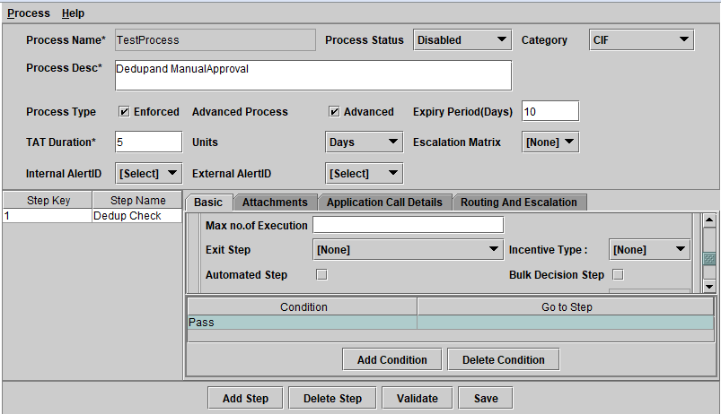*Figure 8: Tabs for Manual step*

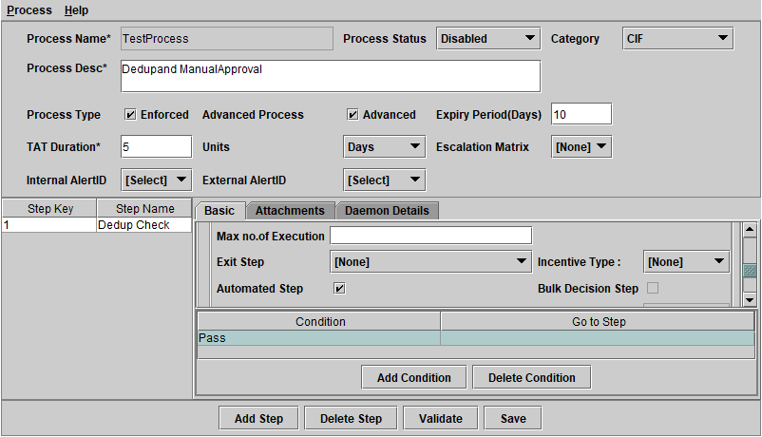

*Figure 9: Tabs for Automated step*

### ***Basic tab***

Basic information about the step is provided in this tab. We also define if the step is Regular/Decision and Manual/Automated.

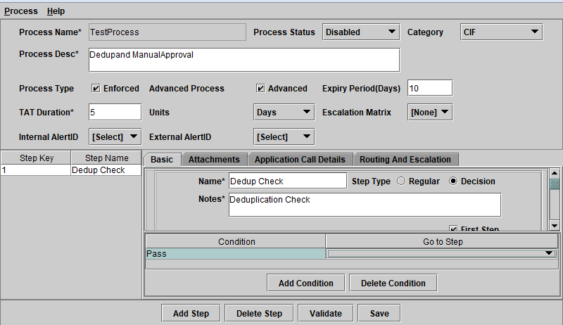

*Figure 10: Basic Tab - 1*

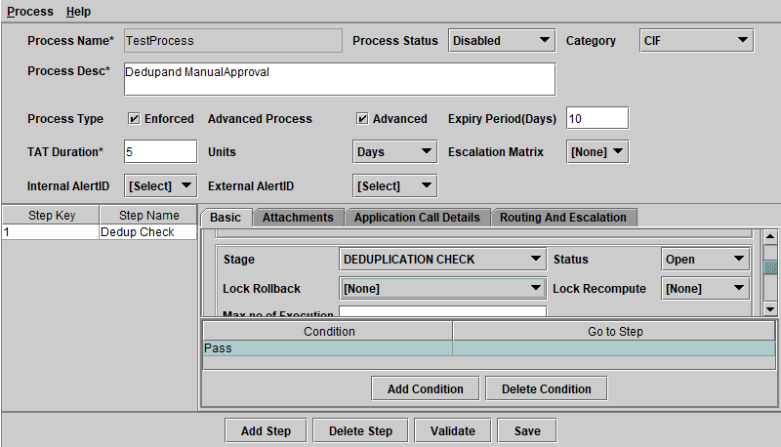

*Figure 11: Basic Tab - 2*



*Figure 12: Basic Tab - 3*

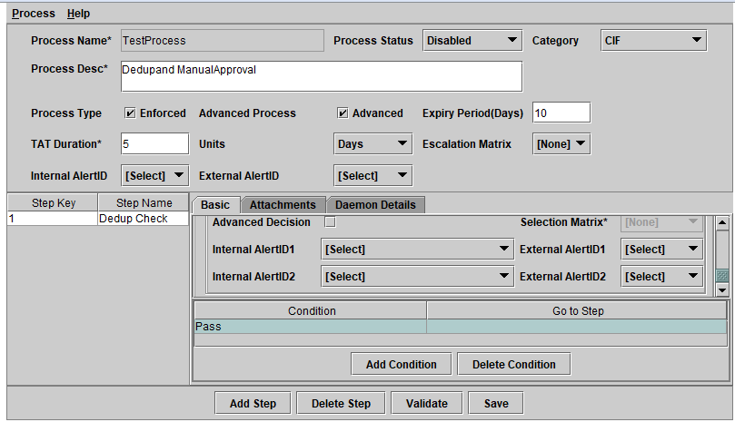[

*Figure 13: Basic Tab - 4*

After selecting Step type the system displays the following:

|  |  |  |
| --- | --- | --- |
| Field | DB Field | Details |
| Name | Processsteps.stepDesc | Identify the step for the user who is handling the process step execution. |
| Step Type | Processsteps.stepType | Regular: Indicates the process moves to only one step after completion of the current process step.  Decision: Indicates the process can move to more than one next step depending on the decision. |
| Notes | ProcessstepDetails.StepNotes | More information about the step to aid the user. |
| First Step | Processsteps.IsFirstStep | While defining the first step of the process, the check box should be selected. There must be one first step in the process. |
| Stage | Processsteps.Stage | List of stage is provided as part of the base product to indicate which stage of the process is reached. Stage is a display field which the user may check for tracking purposes. |
| Status | Processsteps.Status | Valid values: Abandoned, Closed, Open. By default the status is Open for all the Process steps except the Stop step which is the last step of the process. For the Stop step, the status automatically gets updated as Closed. Apart from this, user can specify the status for any of the process steps as Abandoned or Closed. If the status is selected as closed, the record does not appear in the tray on reaching the process step. If the status is selected as Abandoned, the status appears as Abandoned and the user cannot execute process step. Entities with abandoned status need to be closed manually. |
| Lock Rollback | Processsteps.LockRollBack | Valid Values: Y – Yes, N – No. It is possible to rollback the opportunity state to any of the already executed and completed step. The system displays the list of completed steps to which the opportunity can be rolled back. If No is selected, then the rollback is disabled from this step. |
| Lock Recompute | Processsteps.LockRecompute | Valid Values: Y – Yes, N – No. Indicates whether re-computation of values of the specific process step must be allowed or not. |
| Max no.of Execution | Processsteps.Max_No_Of_Execution | Maximum number of times the specific process step can be executed. |
| Exit Step | Processsteps.Exit_Step | If the max number of execution exceeds for any entity, the process will be moved to the step mentioned in this field. Mandatory if Max no.of Execution is provided. |
| Automated Step | Processsteps.IsAutomated | Indicates the step is automated. If selected, Daemon Details tab is enabled. |
| Bulk Decision Step | Processsteps.IsBulkDecision | In case of multiple opportunities or incidents in the same step, it is possible to approve in bulk if this check box is selected. |
| Advanced Decision | Processsteps.IsAdvancedProcess | Advanced Decision Step is used to evaluate a particular Selection Matrix to identify the next step to proceed. This field is enabled only if step type is selected as decision. |
| Selection Matrix | NA | Contains a set of conditions and value associated with each condition. When the process step is being executed, the Selection Matrix configured is evaluated and based on the return value the process is moved to the next step as specified in the conditions grid. |
| Internal Alert ID1 | Processsteps.alertID1 | Internal Email ID to whom an alert can be sent on escalation |
| Internal Alert id 2 | Processsteps.alertID2 | Internal Email ID to whom an alert can be sent on escalation |
| External Alert ID1 | Processsteps.alertID3 | External Email ID to whom an alert can be sent on escalation |
| External Alert ID2 | Processsteps.alertID4 | External Email ID to whom an alert can be sent on escalation |
| Next Step Key | Processsteps.NextStepKey | The next step could be one of the existing steps or a new step to be configured. For the first step, next step lists only two values in the drop-down : New Step and Stop. For all other steps, the drop-down list shows all the existing process step numbers, new step and stop |
| Condition | ProcStepConditions.Condition | Condition can be Pass/Refer/Hold/Close etc. |
| Go to Step | ProcStepConditions.GoToStepKey | Go to Step will define the next step based on the conditions |

### ***Attachments tab***

This is to specify the reference files which the user can view during process step execution.

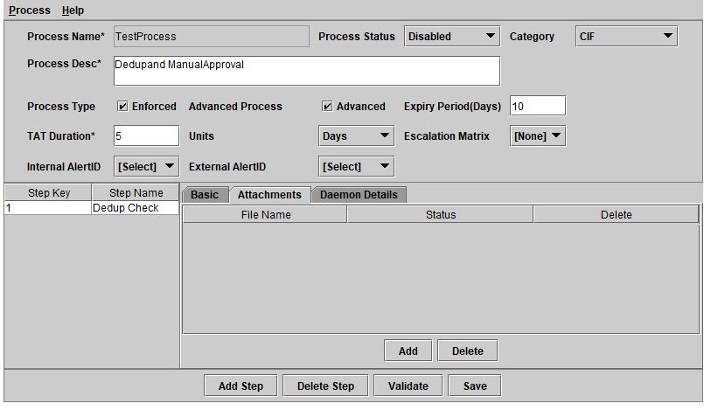

*Figure 14: Attachments Tab*

|  |  |  |
| --- | --- | --- |
| **Field** | **DB Fields** | **Details** |
| **File Name** | ProcStepAttach.FileName | Displays the name of the document attached. |
| **Status** | NA | Displays the status of the document, Valid Values: Added, Existing |
| **Delete** | NA | Select the check box and click Delete to delete an attachment. |

### ***Daemon Details tab***

This tab is enabled when the check box, Automated step is checked in the basic tab. This tab is used to set the parameters for the system to run an automated process.

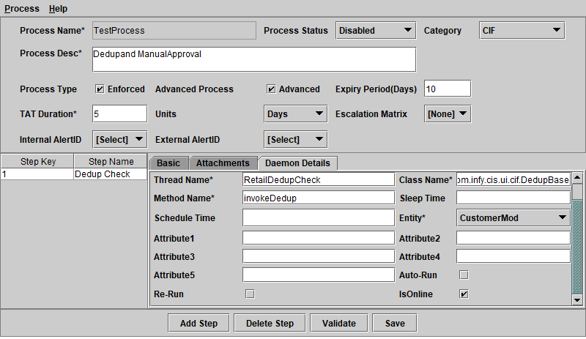

*Figure 15: Daemon Details Tab*

|  |  |  |
| --- | --- | --- |
| **Field** | **DB Field** | **Details** |
| **Pre-defined Threads** | NA | Lists the threads that are predefined in PreDefinedThreads.properties file. If a thread is selected all the remaining fields are defaulted with values. |
| **Thread Name** | ProcStepDaemonInfo.ThreadName | Unique thread name to identify the daemon to be started. More than one process with the same thread name cannot exist. |
| **Class Name** | ProcStepDaemonInfo.ClassName | Class file to be called while running daemon. The list of class files available to specify here is shared as part of the CRM installation. The user must mention any of the available class files as per requirement. |
| **Method Name** | ProcStepDaemonInfo.MethodName | Name of the method that must be called from the class file. |
| **Sleep Time** | ProcStepDaemonInfo.SleepTime | Sleep time in minutes for the thread before it restarts. |
| **Schedule Time** | ProcStepDaemonInfo.ScheduleTime | Start time at which the thread is invoked for the first time in the day if step is not run online. |
| **Entity** | ProcStepDaemonInfo.EntityName | Entity for which the step is to be processed, e.g. Customer, CustomerMod, Corporate etc. |
| **Attribute1 to 5** | ProcStepDaemonInfo.Attrib1-5 | Bank specific attribute used while running Daemon. |
| **Auto Run** | ProcStepDaemonInfo.AutoRun | This ensures that the next automatic process step is executed without waiting for Sleep time. |
| **Re Run** | ProcStepDaemonInfo.ReRun | This is to re compute the values during Re run of the same process step, which may be initiated on account of the rollback. |
| **IsOnline** | ProcStepDaemonInfo.ISONLINE | If this check box is selected the automated step starts immediately after the previous step is completed without waiting for the schedule time. |

### ***Application Call Details tab***

This tab is enabled only when the checkbox, Automated Step is not checked in the Basic Tab. This is to specify the User Interface screen that needs to be displayed to the user to complete the process step execution. The display screen can vary with the process step and hence the appropriate UI form must be specified, otherwise a generic Activity Completion form is loaded.

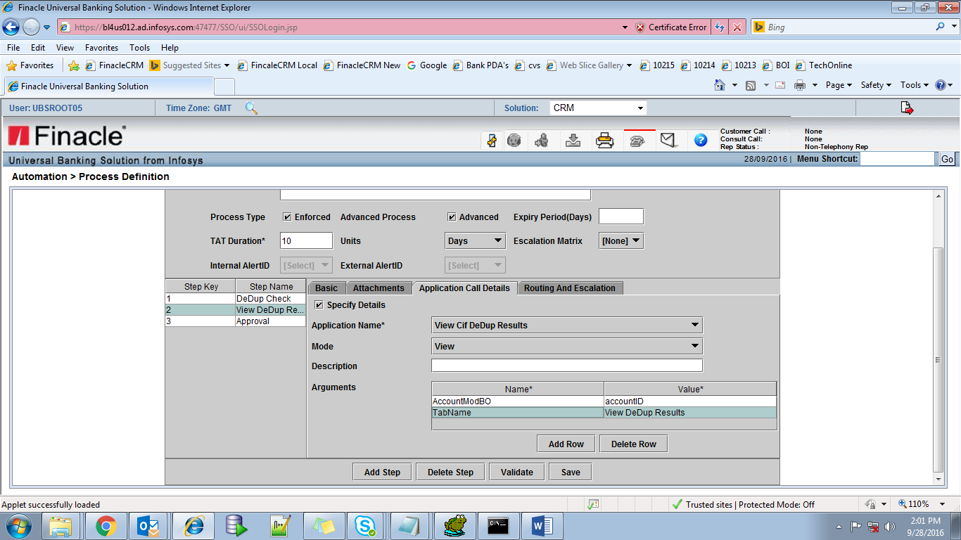

*Figure 16: Application Call Details Tab*

|  |  |  |
| --- | --- | --- |
| **Field** | **DB Field** | **Details** |
| **Specify Details** | - | Default Value: unchecked Un-checked: User gets a default Activity completion form.  Checked: User can specify the form details. |
| **Application Name** | ProcStepAppCallInfo.AppID | The default application forms are available as part of the CRM application installation. |
| **Mode** | ProcStepAppCallInfo.ProcMode | Valid Values: New, Edit, View. Mode of screen opening, whether New data edition or data Edit will be allowed or data will be available for View only. |
| **Description** | ProcStepAppCallInfo.Description | Type the description of the application name. |
| **Arguments** | ProcStepAppCallInfo.Arguments | Type the arguments or attributes used by the application. Multiple Arguments can be added using Add Row tab. This inserts an additional row. During Process modification, certain arguments can be deleted by selecting the appropriate row and selecting Delete Row. |

### ***Routing and Escalation details tab***

Enabled only when the Process step is non automated and Advanced check box is enabled. It is Used for setting up Routing and Escalation logic for the process. The routing is mapped to a specific user or a group. Alternatively, it is possible to map the routing logic to be used for arriving at the user or group for process step assignment and transfer.

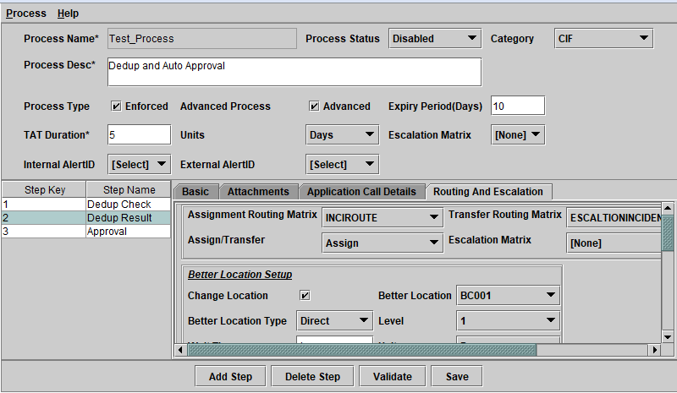

*Figure 17: Routing and Escalation Tab - 1*

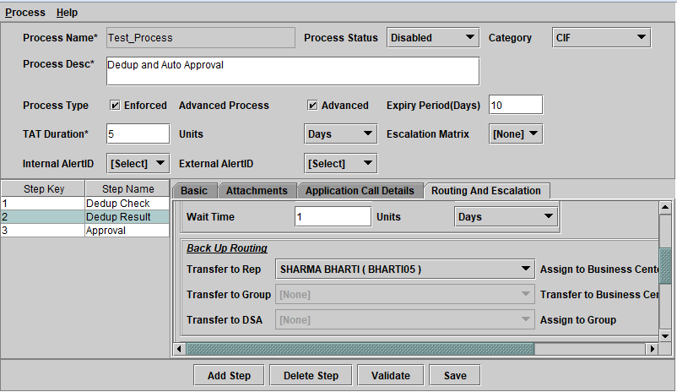

*Figure 18: Routing and Escalation Tab - 2*

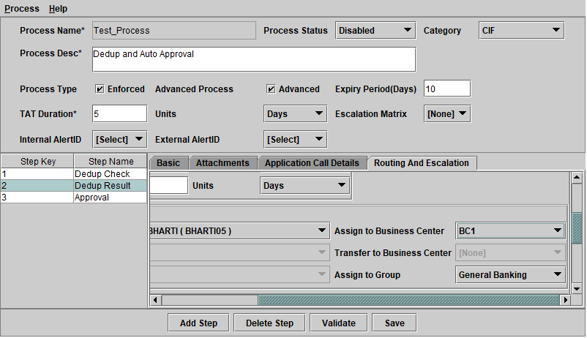

*Figure 19: Routing and Escalation Tab – 3*

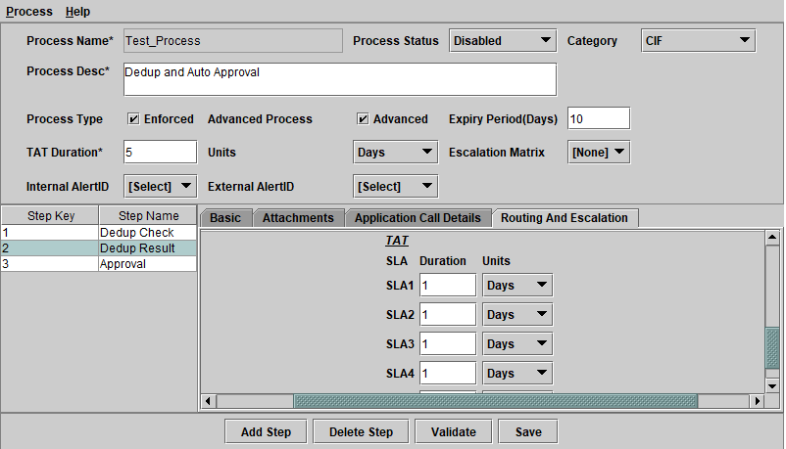

*Figure 20: Routing and Escalation Tab – 4*

|  |  |  |
| --- | --- | --- |
| **Field** | **DB Field** | **Description** |
| **Assignment Routing Matrix** | Processsteps.AssignRoutMatID | Routing matrix to be used for Assignment. |
| **Transfer Routing Matrix** | Processsteps.TransRoutMatID | Routing matrix to be used for Transfer. |
| **Assign/Transfer** | Processsteps.AssignTransfer | Indicate if the process is intended to be assigned or transferred or both. |
| **Escalation Matrix** | Processsteps.EscalationMatrix | Escalation matrix logic to be applied for the process step. The escalation matrix logic is applied if escalations by e-mail is required based on TAT and number of assignments and transfers within a process step. |
| **Better Location** | | Better location can be a direct location, derived location at a level specified, or a custom location where the customization logic decides on the better location for routing. |
| **Change Location** |  | Indicate whether changing of location is required for routing logic. This is applicable only when the Routing matrix is used for assignment and transfer. If checked, it enables the user to type the values for the following fields. |
| **Better Location** | Processsteps.Better_Location | A specific location for better location computation. |
| **Better Location type** | Processsteps.BetterLocationType | Better location type from the list of values. |
| **Level** | Processsteps.BetterBC_Level | Business centre group level for better routing. |
| **Wait time** | Processsteps.Waittime | Type the time to be computed for better location logic. Once the entity for better location is identified from the selected location and the better location, the entity is assigned to a location which has the earliest due date. The option Level can be configured for all the options except the Direct option. If the Business center selected is at the lower level than the level specified in the routing rule, then the entity is routed to the corresponding business center at the specified level. This can be derived from the relationship maintained between the business centers. If the level specified in the rule is lesser than the level of the selected business center then the entity remains in the selected business center. The better location logic is used only when the wait time to start the process step is greater than the wait time specified here in the process step. |
| **Back up Routing Logic** | | The backup routing logic is validated when the assigned Routing logic is not run for any reason or is not deployed for a process step. |
| **Transfer to Rep/Group/DSA/Business Centre** | Processsteps.TransferToBC | Rep/Group/DSA/ Business Centre to whom the step should be transferred from the list of values. |
| **Assign to Business Centre /Group** | Processsteps.AssignToBC | Group/Business centre to whom the current step should be assigned from the list of values. |
| **TAT** | | Turnaround time defined based on the SLA parameters. |
| **SLA 1-5** | ProcessSteps.SLA1Duration, SLA1Unit… | 5 levels of SLA can be defined in the system |

­